1. Overview of Continuous Delivery

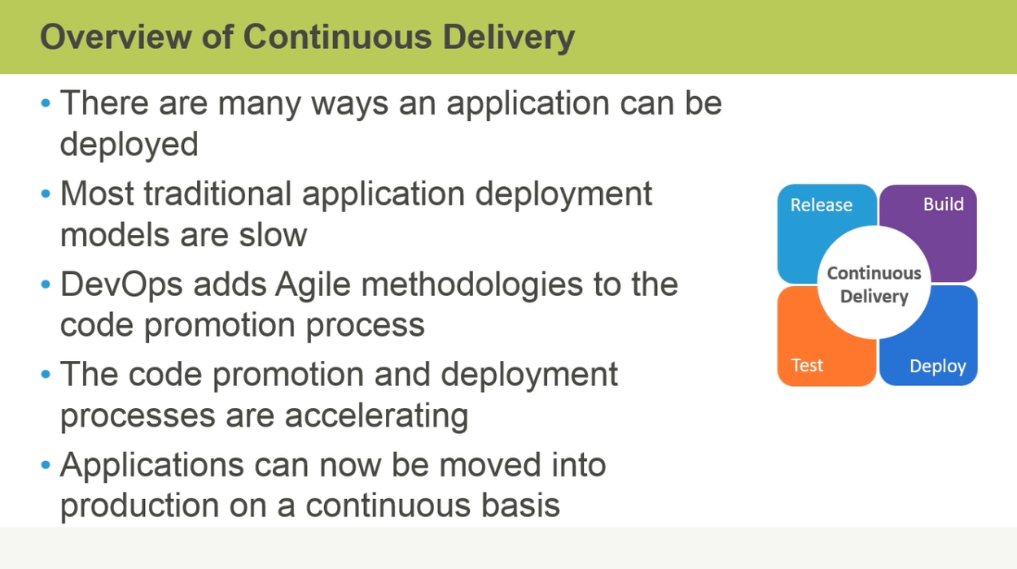

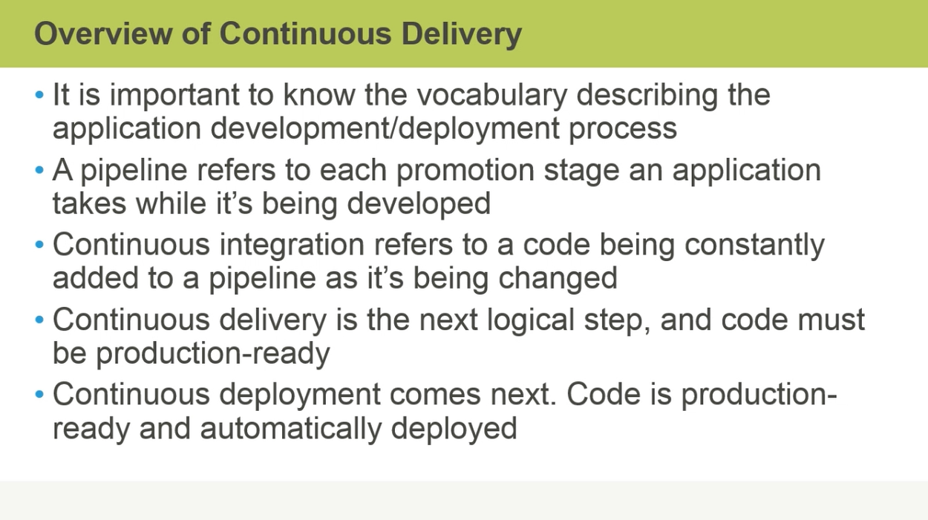

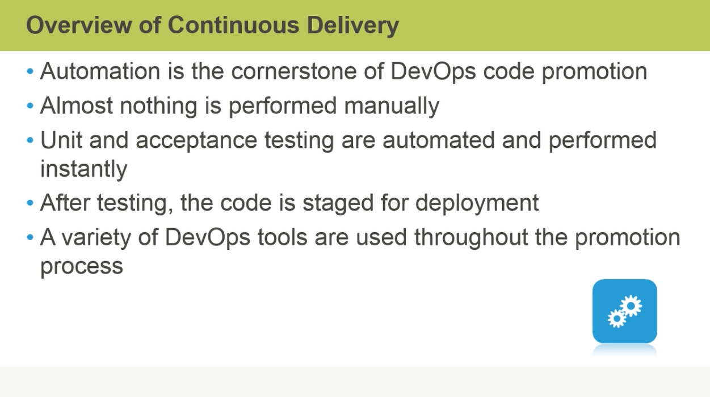

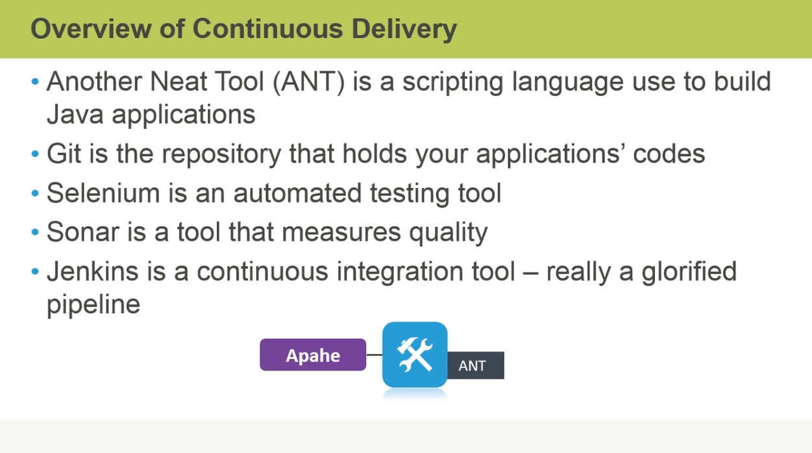

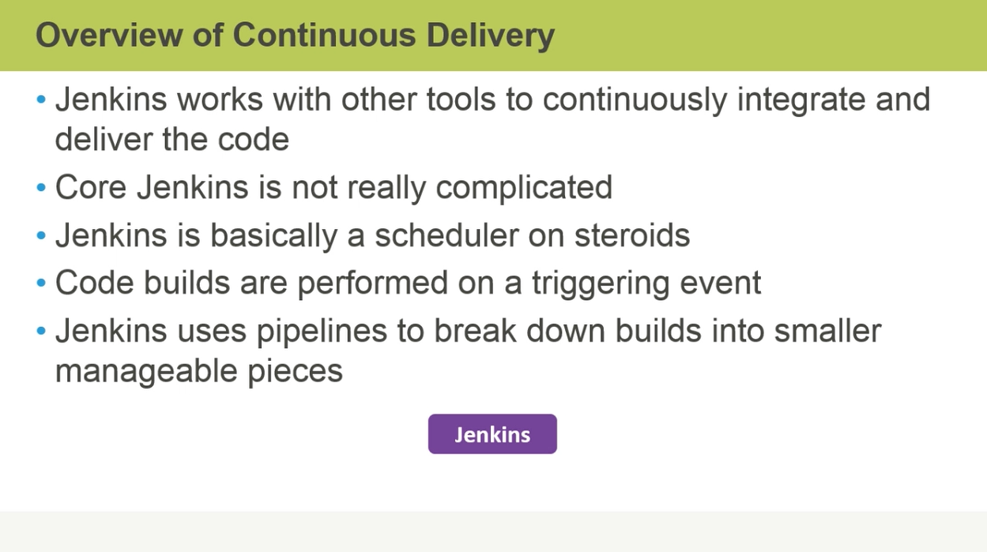

Jenkins as Continuous Delivery Tool:

Jenkins is a Java Application and it runs in a servlet container. Technically it is not java application, it is server side java application or server side component. So it does run on servlet container that means it run like a web application.

If you have http server such as apache tomcat, you can deploy Jenkins as war file and actually server set Jenkins up as a full fledge web app.

You can also run Jenkins as standalone means you are not running an enterprise server like apache tomcat or any other large ones and you are running Jenkins on small servlet container.

Jenkins actually downloads and install and run as java web start application. So 3 different ways we can actually run Jenkins.

On your local machines you need java, and java support on your machine other than that you do not need much.